ART
‘Every human is an artist’
Don Miguel Ruiz
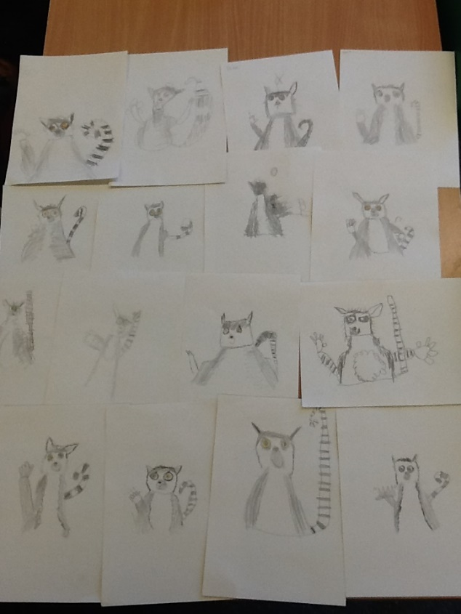

Select, Ctrl and Click on the policy and progression maps below for more details
Art Policy
Assessment Tracker - Year 1
Assessment Tracker - Year 2

This page is still being updated

