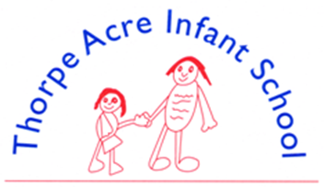

ENGLISH - WRITING
‘Reading and writing float on a sea of talk’
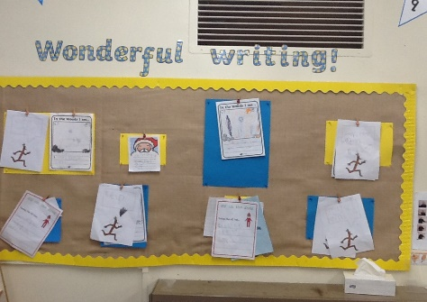
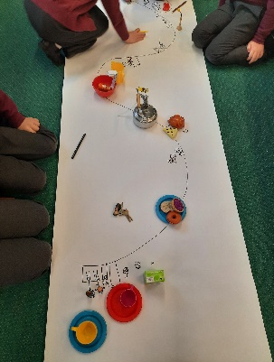
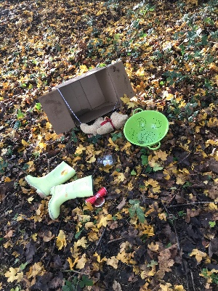
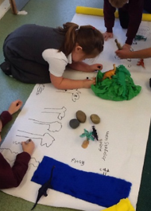
James Britton

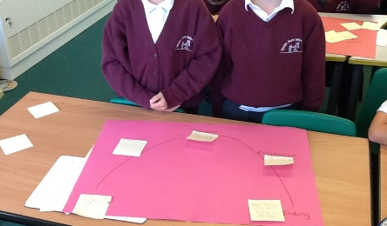

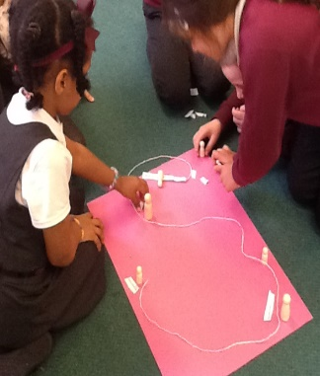
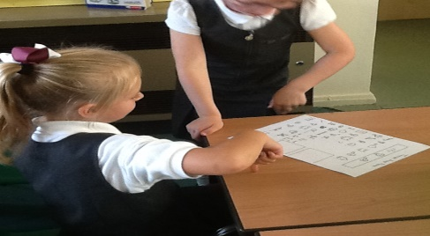

In Thorpe Acre Infant School we follow Pie Corbett's 'Talk for Writing' approach. Talk for Writing is used to teach fiction, non-fiction and poetry through a multi-sensory approach. This ensures that there are plenty of opportunities for children to talk, share experiences and explain their thinking.
Writing is taught with an emphasis on the skills of writing for different purposes, such as writing to entertain or writing to inform, but it is also taught through other subjects such as science, history and geography.
Pupils develop skills in speaking, listening, reading and writing. It enables them to express themselves creatively and imaginatively and to communicate with other effectively.
Vocabulary development is a priority across the curriculum. Exciting language is taught and discussed in English and other subjects, with children encouraged to use these in their writing.

Select, Ctrl and Click on the policy and progression maps below for more details
Handwriting Policy
Spelling and Phonics Policy
Writing Progression Map
Grammar Progression Map
End of KS1 Assessment Criteria

