MATHS
"Good Mathematics is not about how many answers you know…it’s how you behave when you don’t know.” -Unknown
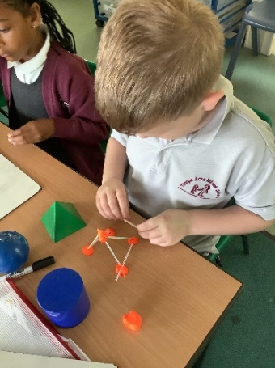
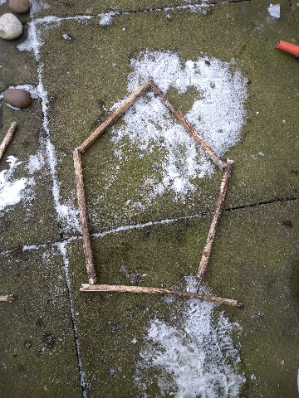

We use the National Curriculum for Mathematics (2014) in conjunction with White Rose Mastery materials (EYFS through to Year 2) as the basis of our mathematics programme.
Our key aims are to ensure that children become fluent in the fundamentals of mathematics, they reason mathematically and can solve problems by applying their maths to a variety of routine and non-routine problems.
Pupils are taught through whole-class interactive teaching, where the focus is on all pupils working together on the same lesson content at the same time. This ensures that all can master concepts before moving to the next part of the curriculum sequence, allowing no pupil to be left behind. Our lesson design identifies the new mathematics that is to be taught, the key points, the difficult points and a carefully sequenced journey through the learning. In a typical lesson, pupils sit facing the teacher and the teacher leads back and forth interaction, including questioning, paired work and independent tasks.

Here is what we teach when:
EYFS Yearly Overview
Week | 1 | 2 | 3 | 4 | 5 |  | 6 |  | 7 | 8 | 9 |  | 10 |  | 11 |  | 12
Autumn | Number: Sorting | Number: Comparing groups | Number and Place Value: 1, 2, 3 |  | Number and Place Value: 4 and 5 |  |  |  | Geometry | Number: Addition and Subtraction: One more, One less |  |  | Measurement: time | Spatial Awareness |  |  | Simple Patterns
Spring | Measurement: Size, mass, capacity | Measurement: Length and Height | Number and Place Value: Number bonds to 4 and 5 |  | Number and Place Value: Numbers to 10 |  |  |  |  | Number: Addition (within 10) |  |  |  | Comparing size, mass, capacity |  |  | Measurement: time
Summer | Number and Place Value: numbers to 20 |  | Geometry and Spatial Reasoning 1 | Number: Addition and Subtraction: counting on and back |  | Geometry and Spatial Reasoning 2 |  | Multiplication and Division: numerical patterns |  |  |  | Geometry: exploring patterns |  | Geometry and Spatial Reasoning 3 |  | Consolidation

Year 1 Yearly Overview
Week | 1 | 2 | 3 | 4 | 5 |  | 6 | 7 | 8 | 9 | 10 | 11 | 12
Autumn | Number: Place Value  (within 10) |  |  |  | Number: Addition and Subtraction  (within 10) |  |  |  |  | Geometry: Shape | Number: Place Value (within 20) |  | Consolidation
Spring | Number: Addition and Subtraction  (within 20) |  |  |  | Number: Place Value  (within 50 including multiples of 2,5,10) |  |  |  | Measurement: Length and Height |  | Measurement: Weight and Volume |  | Consolidation
Summer | Number: Multiplication and Division  (reinforcing multiples of 2,5,10) |  |  | Number: Fractions |  | Geometry: Position and Direction |  | Number: Place Value  (within 100) |  | Measurement: Money | Measurement: time |  | Consolidation

Year 2 Yearly Overview

Week | 1 | 2 |  | 3 | 4 |  |  | 5 | 6 | 7 | 8 | 9 | 10 | 11 |  | 12
Autumn | Number: Place Value |  |  |  |  | Number: Addition and Subtraction |  |  |  |  |  | Measurement: Money |  | Statistics
Spring | Number: Multiplication and Division |  |  |  |  |  | Geometry: Shape |  |  |  | Measurement: Length and Height | Number: Fractions |  |  | Consolidation
Summer | Consolidation |  | SATs |  |  |  | Measurement: Mass, Capacity and Temperature |  |  | Measurement: Time |  | Geometry: Position and Direction |  | Consolidation

Select, Ctrl and Click on the links below for more information about Maths learning in school
Maths Policy
Calculation Policy
EYFS - End of Year Assessment
Year 1 - End of Year Assessment
Year 2 - End of Year Assessment
Progression Maps

