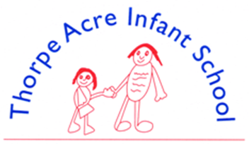
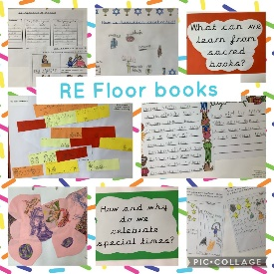

R.E
‘RE is like an iceberg. As you unpack ideas, you come to understand deeper meaning’
RE is taught discretely following the Leicestershire RE Syllabus.
The principal aim of our RE curriculum is:
To explore what people believe and what difference this makes to how they live, so that our children can gain the knowledge, understanding and skills needed to handle questions raised by religion and belief, reflecting on their own ideas and ways of living.
Our lessons are planned using key questions to allow children to explore key ideas of religions and to consider their place within a diverse multi – religious and multi-secular society. We teach about religions systematically across the year with a thematic unit at the end of each Academic Year. Longer units in Key Stage One which focus on Judaism and Islam are split into two parts to allow opportunities for recall and retrieval of learning before further development of knowledge and understanding.
Our RE long term planner:
 | Autumn 1 | Autumn 2 | Spring 1 | Spring 2 | Summer 1 | Summer 2
EYFS | Being Special  Where do we belong? | Why is Christmas special for Christians? | Why is the word ‘God’ so important to Christians? | Why is Easter special to Christians? | What places are special and why? | What times / stories are special and why?
YEAR 1 | 1.10 What does it mean to belong to a faith community? | 1.1 What do Christians believe God is like? | 1.7 Who is Jewish and how do they live?  Part 1 | 1.2 Who do Christians say made the world? | 1.7 Who is Jewish and how do they live?  Part 2 | 1.9 How should we care for the world and others and why does it matter?  (C,J,NR)
YEAR 2 | 1.6 Who is a Muslim and how do they live? | 1.3 Why does Christmas matter to Christians? | 1.6 Who is a Muslim and how do they live?  Part 2 | 1.5 Why does Easter matter to Christians? | 1.4 What is the ‘good news’ Christians believe Jesus brings? | 1.8 What makes some places sacred to believers? (C,M)
Select, Ctrl and Click on the links below for more information about RE learning in school
Our RE Policy is being updated. A link will appear here soon!
Leicestershire Agreed Syllabus for RE

