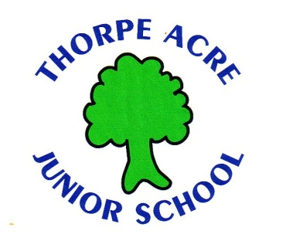
Alan Moss Rd Loughborough Leics LE11 4SQ
Tel: 01509 212021 Tel: 01509 214974
Executive Headteacher: Jo Beaumont Executive Headteacher: Jo Beaumont

LEAVE OF ABSENCE APPLICATION FORM

SCHOOL…………………………………........…………………. DATE of APPLICATION ………………………….

NAME OF CHILD……………………………………………………………………. DOB…….............................

START DATE ………………........................................ RETURN DATE………………………………………

PARENT NAME Mr/Mrs/Ms/Miss …………………………………………………………............................

Please provide full details for the reasons for this request.

- What are the reasons for your child’s leave of absence?

Please note under the government’s new guide lines it is at the Head’s discretion as to whether this request is accepted or declined. This depends on whether the request meets criteria for exceptional circumstances. Parents taking their child out of school where the request has been declined leave themselves at risk of a penalty notice and/or prosecution. Your child may also be removed from the school roll and you will have to re-apply to the Local Authority for a place.

Parent’s Signature …………………………………………………………………….. Date………………………………………

OFFICE USE
Accepted Declined DATE ………………...............

Head……………………………………………………………………………………………………………

